File Compression GUI: Manual

Julian Chan, Undergraduate Summer Intern 2017

Updated: August 8, 2017 1:58 PM

**Program Overview**

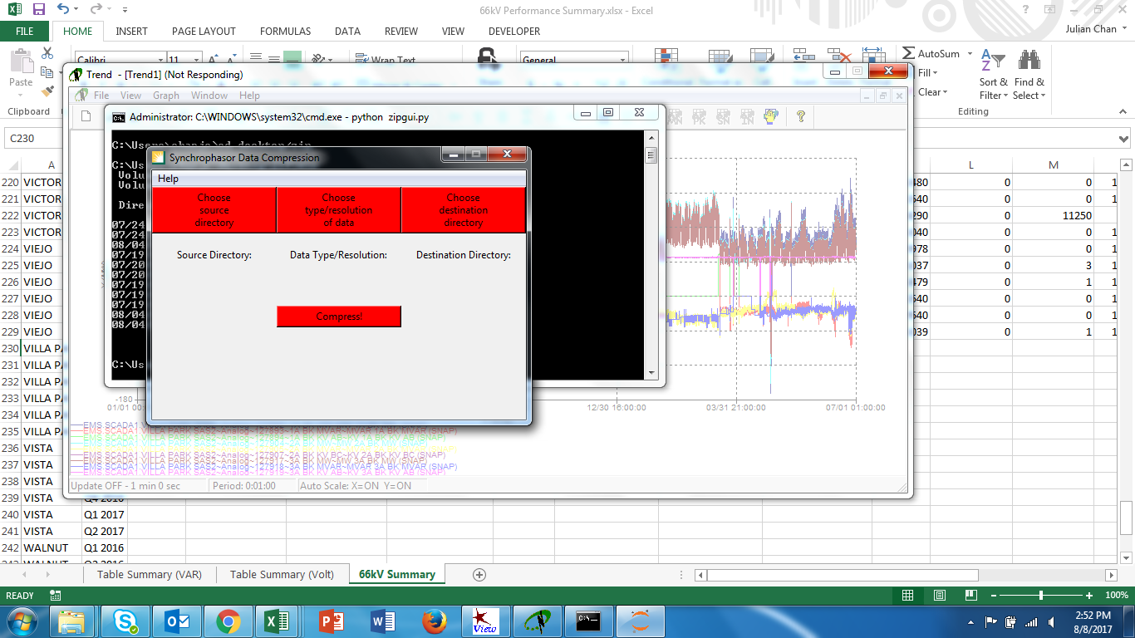

This program was written for compressing Synchrophasor Data (.dst files). This program supports compression of the following types of files:

* 90-minute files (SCEC)
* 9-hour files (SCED)
* 24-hour files (SCEK)
* 90-hour files (SCEM)
* 120-hour files (SCEW)
* Stream Data files (SCEP)
* Monolith PMU files (SCET)

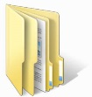Please see below for assumptions made by this program regarding file structure (xxx = 3 letter abbreviation of the month):

Stream Data

SCEP_YYMMDDhhmm.dst

YYMM_xxx



Monolith PMU

SCET_YYMMDDhhmm.dst

MonolithData_YYMM



90-minute

SCEC_YYMMDDhhmm.dst





9-hour

SCED_YYMMDDhhmm.dst

Source Directory



24-hour

SCEK_YYMMDDhhmm.dst



90-hour

SCEM_YYMMDDhhmm.dst



120-hour

SCEW_YYMMDDhhmm.dst

**How to Run the Program**

(IMPORTANT: User must have Python 3.6 installed and added to the system PATH environment variable. If Python installed using the Anaconda distribution, everything should work smoothly.)

|  |  |
| --- | --- |
| Locate the file called *zipgui.py* |  |
| Right-click the file 🡪 Properties 🡪 General 🡪 Location 🡪 Copy the entire path |  |
| Open command prompt by pressing Windows + R, typing “cmd”, and pressing Enter |  |
| On the command line, type “cd “ and then Right-click 🡪 Paste to paste the entire path of the *zipgui.py* file |  |
| On the command line, type “python zipgui.py” and the GUI will start up |  |